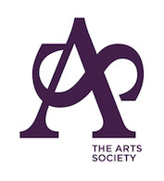

THE ARTS SOCIETY WIRRAL
Notice of Annual General Meeting
Heswall Hall Monday 16th March 2026 at 2pm.

Agenda

- Apologies.

2. Minutes of the Annual General Meeting held on 17th March 2025 be adopted.

3. RESOLUTION: That the Committee Reports for 2025/26 be adopted.

4. RESOLUTION: That the statement of Accounts for 2025/26 be adopted

5. RESOLUTION: That Mr C. N. H. Pursglove FCA be re-appointed Independent Examiner of Accounts for the year 2026/27

6.Election of Committee Members for the year 2026/27.
RESOLUTION: That the Committee Members for the year 2026/27 be elected as per the list of nominees below.

7. Election of Honorary Officers for the year 2026/27 RESOLUTION: That the Honorary Officers for the year 2026/27 be elected as per the list of nominations below.

9. Date of next Annual General Meeting : Monday March 15th 2027

