Wirral Arts Society (Young Arts) Donation

Thank you for your generous donation of £250 towards Heswall Camp 2025.
This year we offered free places on a residential holiday camp to 35 disabled children and additionally 5 others who were unable to stay overnight due to their care needs. All of the children were from the immediate area and would not be able to attend any summer schemes because of their disabilities without out support.

The theme for 2025 was ‘I’m a Camper, Welcome to the Jungle’. We had a range of activities throughout the week to match the theme including exotic animals, kayaking, drumming and forfeits with huge amounts of gunge.

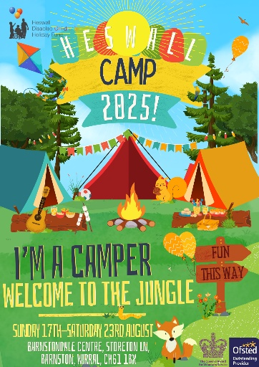
The donation from Wirral Arts Society was well spent on materials we could use for drawing and painting, sensory arts using coloured rice and scented foam, making costumes and props for the theme and a range of projects which the children could build and take home. These included bird feeders, bee houses, bug hotels, felt insects, nature crafts, stickers and activity books.

We began the week with a huge banner, which the volunteers started and helped the children to colour in and make their own. Each team created their own posters filled with their names, favourite things and some important things to remember on camp such as friendships and making memories.
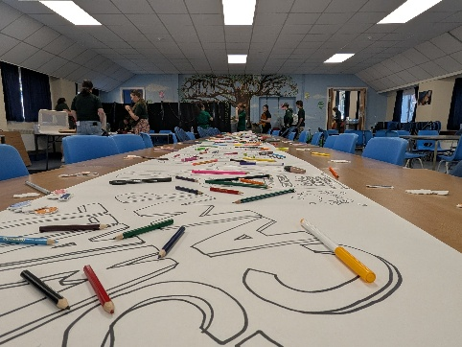
As the week went on, we kept adding to the creativity and used the materials to create masks and costumes. Not only did we have ready-made projects, but the materials meant our children and volunteers could use their own creativity and respond to their needs and ambitions.

The week always ends in a fantastic party and many of the costumes and art were displayed and used again in the hall to create a brilliant atmosphere. This included face painting led by some of our more creative volunteers and really added to the fun.
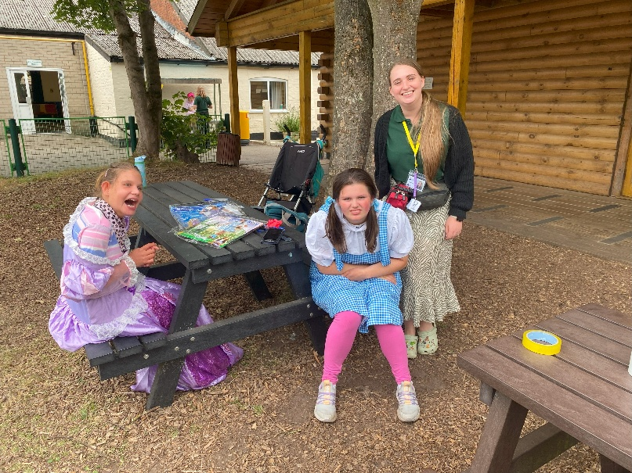
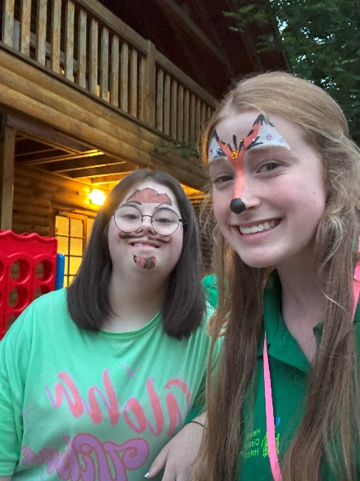
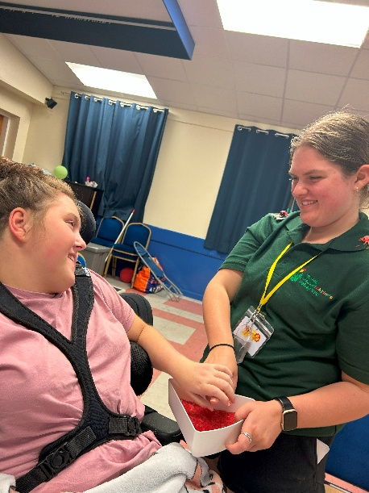
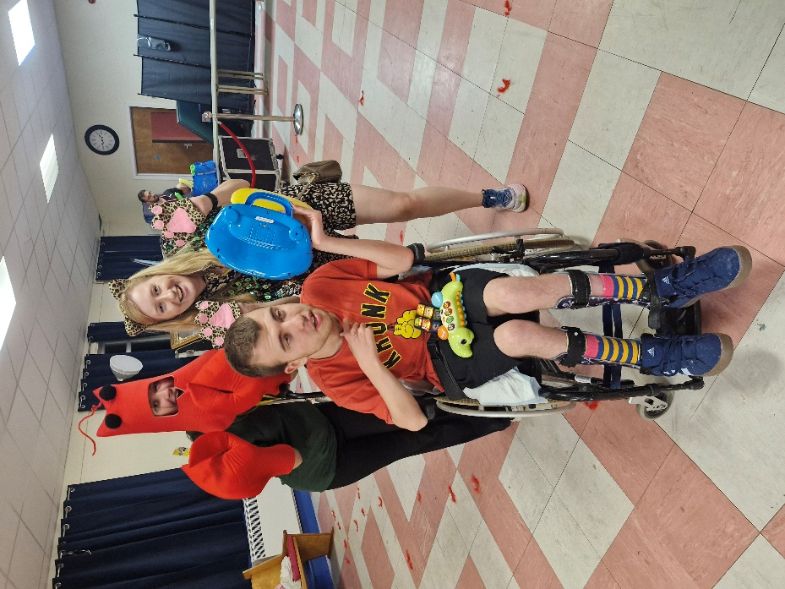
DANIEL – FIRST TIME CAMPER
Thank you SO much from the bottom of OUR HEARTS. DANIEL hasnt stopped asking to go back. He enjoyed his CAMP to the hilt and the independence he HAD is something he could never have withOUT YOU. THE team were attentive, caring, organised, patient, on the ball. you do a FANTASTIC job when there are so many vulnerable kids to look after. You have made this an unforgettable experience for my little fella that he will remember for the rest of his life.

The land of Wheelchairs – by Charlie

If you are in a WHEELCHAIR, you might feel alone
If you are in a WHEELCHAIR, you might feel sad
But you might find, my old friend,
A land that suits you.
You call that, the land of wheelchairs,
where disabled people go when they are sad.
There you find animals and wheelchair users that make you part of the tribe.
People from all over make up a family in the land of wheelchairs.
To most people this land will remain unknown, like it doesn’t exist
The land of wheelchairs is a happy place
A land where you will not feel like a social reject.

When He got home, Charlie wrote this poem and announced “I found MY land of wheelchairs. I knew it existed and it does!”
CAMP really was a special time for Charlie.

TOBY – RETURNING CAMPER
Thank you is just not enough.
The confidence and independence this camp gives to our children is immeasurable.
They absolutely love it and enjoy experiences with their friends in ways we just cannot match.
To find a camp that has this CAN-DO attitude AND matches - no, exceeds our EXPECTATIONS- is like it’s own miracle.
For Toby to get to do this on his own residential holiday with people he knows as good friends is so amazing and we are forever grateful.
Also, for us to do things with the other siblings and give them some of their own time with us helps us strengthen our family bonds. At the end of camp when we get to hear other peoples stories of Toby, that warms our hearts and just makes us appreciate him even more.
Thank you everyone at Heswall camp.
We love and admire you so much - you are all in our hearts forever xxxx

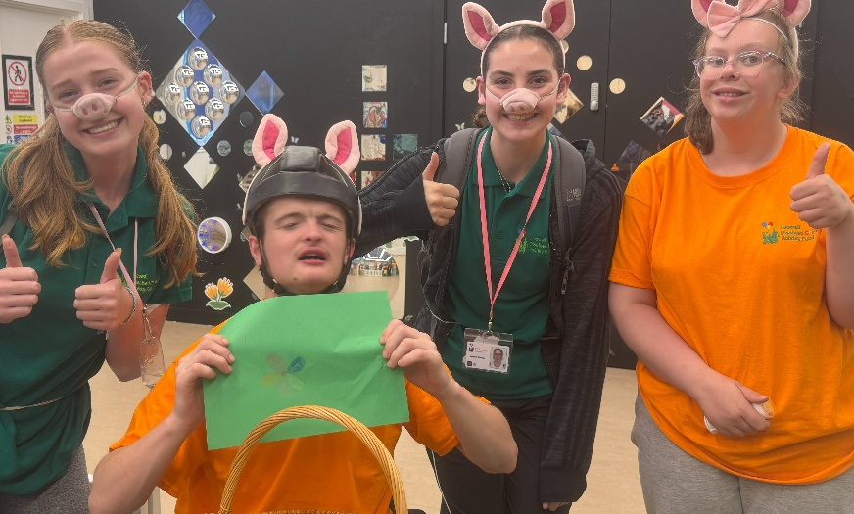

Thank you to everyone at Wirral Arts Society for helping to make this camp happen, many of you we have never met before but truly appreciate. I would like to thank Siobhan McCormick and Martin Amlôt who have supported me in securing this donation personally.

Sincerely,
Vinny Keating and everyone at Heswall Disabled Children’s Holiday Fund

